KCA UNIVERSITY
SCHOOL OF TECHNOLOGY
BACHELOR OF INFORMATION TECHNOLOGY

SOFTWARE DESIGN SPECIFICATION
CozyStay
Furnished Short-Stay Accommodation and Booking Management System

PREPARED BY
Zubeda Obwoge
Registration Number: 25/09770
Bachelor of Information Technology (BIT)

Version 1.2 | 26 October 2026
Revised draft for supervisor review

Approval record
Document: CozyStay Software Design Specification (SDS) | Version 1.2 | Revised draft for supervisor review

Decision
Mark one: Approve / Approve with changes / Revise and resubmit

Academic supervisor
Name: ______________________________________________
Signature: __________________________________ Date: __________________

Project stakeholder / owner
Name: ______________________________________________
Signature: __________________________________ Date: __________________

Table of Contents
Approval record 2
Decision 2
Academic supervisor 2
Project owner 2
Document control 4
Purpose and document status 4
1. Executive summary 4
2. Goals, scope, and assumptions 4
2.1 Goals 4
2.2 In scope 5
2.3 Assumptions and boundaries 5
3. System context and architecture 5
3.1 Architectural style 5
3.2 Major components 5
4. Component and responsibility design 6
4.1 API modules 6
4.2 Client responsibilities 7
5. Data design 7
5.1 Key records 7
5.2 Consistency rules 7
6. Interfaces and key workflows 8
6.1 API conventions 8
6.2 Booking and payment flow 8
6.3 POS walk-in flow 8
6.4 Synchronization flow 8
7. User, software, hardware, and communication interfaces 9
7.1 User interface design 9
7.2 Software interfaces 9
7.3 Hardware interfaces 9
7.4 Communication interfaces 9
8. Transaction and state design 10
8.1 Booking creation 10
8.2 Payment and receipt 10
8.3 Status ownership 10
9. Security and privacy design 10
10. Deployment and operations 11
10.1 Environments and configuration 11
10.2 Resilience and recovery 11
11. Quality attributes and design constraints 11
12. SRS coverage and verification crosswalk 12
13. Risks, decisions, and verification items 13
Appendix A. Traceability to repository material 13
Appendix B. Acronyms 13
Appendix C. System Design Figures
Appendix D. Extended Component Design
Appendix E. Research and Design Basis

Document control
Document title: Software Design Specification (SDS). System: CozyStay Furnished Short-Stay Accommodation and Booking Management System. Author: Zubeda Obwoge (25/09770). Institution: KCA University, School of Information Technology. Version: 1.2, 26 October 2026. Status: Revised draft for supervisor review. Approval decision and signatures are recorded at the end of this document.
Source baseline: CozyStay_Software_Requirements_Specification.docx, version 1.1 dated 16 October 2026, together with the repository documentation listed in Appendix A. The source SRS remains under review. This SDS is a revised draft for supervisor review and does not represent an approval decision or acceptance-test result.

Purpose and document status
This Software Design Specification translates the CozyStay requirements and repository evidence into a logical and deployment design. It describes structure, responsibilities, interfaces, data, security boundaries, workflows, and verification. Where the SRS or repository describes a capability whose end-to-end implementation is not established, this document marks it as conditional or requiring verification.

1. Executive summary
CozyStay is a multi-channel rental operations platform for property discovery, booking, payments, guest services, and staff operations. A central Node.js/Express API owns shared business rules and persistent booking and payment facts. Customers use a React web application; staff use an Electron-based admin client and a Windows POS client. MySQL is the central system of record. Desktop clients may use local SQLite for continuity and queued work, with synchronization through the API.
The design favors a modular monolith for the backend and independently deployable client applications. This keeps deployment and transactional logic manageable while supporting different customer and staff workflows. Payment status, booking status, review eligibility, and authorization decisions remain server-owned.

2. Goals, scope, and assumptions

2.1 Goals
- Provide one consistent property catalog and booking lifecycle across web, admin, and point-of-sale channels.
- Support Kenya-first operations, including KES pricing and M-Pesa payment initiation and callback reconciliation.
- Allow staff to continue selected operations during network interruptions using desktop local storage and a synchronization queue.
- Protect customer data and operational actions through authentication, role-based authorization, validation, and auditability.
- Provide reports and operational views for bookings, payments, occupancy, revenue, shifts, and guest services.

2.2 In scope
The design covers property and availability management; customer accounts; bookings and lifecycle transitions; payment collection, receipts, and refunds; reviews and moderation; pickup and meal/restaurant service requests where enabled; arrival notes; staff communications; cashier shifts and walk-in sales; reporting; local desktop persistence and synchronization; deployment and operations.

2.3 Assumptions and boundaries
- The repository identifies MySQL as the central database, SQLite in desktop clients, Express/Node.js for the API, React/Vite for web clients, Electron for the admin client, and .NET/WPF for POS.
- Docker Compose is the documented deployment path for the customer website, backend, and MySQL. Desktop clients run natively on workstations.
- External payment, email, mapping, and real-time providers are integrations. Credentials are supplied through environment configuration and are not stored in source control.
- Offline behavior and conflict resolution require verification against the current implementation before being treated as production guarantees.

3. System context and architecture
Logical request path: Customer browser / Admin desktop / POS desktop -> HTTPS API -> application services -> MySQL. The admin and POS clients additionally use local SQLite for supported offline work and a sync outbox. The API communicates with payment providers and other configured external services. The browser and POS retrieve public branding settings from the API.

3.1 Architectural style
The backend is a modular monolith organized around domain areas and REST endpoints. This approach centralizes validation, authorization, pricing, state transitions, and persistence while avoiding distributed transactions across services. Client applications are separate presentation and workflow surfaces. Shared TypeScript definitions and validation schemas are maintained in the shared package where applicable.

3.2 Major components
- Customer web: React/Vite application for property search, details, availability, booking, checkout, account, receipts, wishlist, reviews, arrival details, and add-on selection.
- Backend API: Express application providing authentication, properties, bookings, payments, users, reports, reviews, guest services, staff operations, and configuration endpoints.
- Admin client: Electron/React application for property and booking administration, staff operations, reporting, and synchronization-aware workflows.
- POS client: Windows desktop application for walk-in bookings, cashier payments, receipts, shift open/close, and reconciliation.
- Central database: MySQL stores authoritative accounts, properties, bookings, payments, receipts, reviews, and operational records.
- Local stores: SQLite databases support desktop workflows and pending synchronization records when configured.
- External services: configured payment providers (including M-Pesa and card/PayPal options where enabled), email/notification delivery, optional Firebase real-time features, and optional mapping services.

4. Component and responsibility design

4.1 API modules
Each module exposes a route/controller boundary, validates inputs, invokes business logic, and persists through database access code. Authentication and authorization middleware are applied before protected operations. The API returns a consistent JSON envelope and HTTP status codes. Core modules include:
- Identity and access: registration, login, token verification/refresh, profile management, staff role checks, and optional second-factor flows.
- Property catalog: listing creation and updates, search/filter/pagination, image metadata, amenities, pricing, status, and availability queries.
- Booking: date and guest validation, availability protection, server-calculated totals, state transitions, cancellation, arrival information, and booking line items.
- Payments and receipts: payment initiation, provider callbacks, payment status reconciliation, refunds, cash collection, and receipt records.
- Reviews: booking ownership and completed-stay eligibility checks, one-review constraint, moderation, and verified-stay display.
- Guest services and staff inbox: service request review and fulfillment, pickup assignment/progress, meal or restaurant order posting where enabled, and role-aware staff messaging.
- Reporting and audit: operational KPIs, revenue and occupancy queries, exports, and traceable administrative changes.

4.2 Client responsibilities
Clients render workflows, gather user input, provide immediate feedback, and call the API. They may perform presentation-level validation but do not decide authoritative booking, payment, discount, tax, or review status. Staff-only actions are exposed only to authenticated roles and must be re-authorized by the API.

5. Data design
The relational model centers on users, properties, bookings, and payments. Supporting entities represent property images and amenities, receipts, cashier shifts and transactions, reviews and moderation, wishlists, guest service requests, staff messages, housekeeping/maintenance state, audit records, notifications, and sync logs. Some entities are design requirements rather than confirmed central schema tables; reconcile them with database migrations before implementation. Foreign-key relationships and unique constraints should enforce ownership and cardinality where appropriate.

5.1 Key records
- User: UUID, unique email, contact details, role, account status, credential hash, optional 2FA state, timestamps.
- Property: owner, type, description, address/location, capacity, bedrooms/bathrooms, price plans, status, and timestamps.
- Booking: property and customer references, check-in/out, guest count, source, status, server-calculated amount, arrival data, and timestamps.
- Payment: booking reference, amount, payment method, status, unique provider transaction reference, issuer, notes, and timestamps.
- Service line item: booking reference, selected service, quantity/price snapshot, status, assignment and fulfillment details as supported.
- Review: property, customer, eligible completed booking, rating, comment, moderation status, and timestamps.

5.2 Consistency rules
- Availability checks and booking creation must be protected against overlapping confirmed stays; enforce this in a transaction or equivalent concurrency-safe mechanism.
- Payment callbacks must be authenticated and processed idempotently; client success is shown only after server-confirmed payment state.
- Booking totals, discounts, VAT, deposits, and balances are calculated and persisted by the backend using a recorded price breakdown.
- A review is accepted only for an eligible completed booking owned by that customer; duplicate reviews are rejected and new reviews await moderation.
- Offline sync operations require stable IDs, timestamps, retry state, and explicit handling for duplicate delivery and conflicts.

6. Interfaces and key workflows

6.1 API conventions
The documented API base path is /api. Protected requests use an Authorization: Bearer token header. Success responses include success and data fields; failures include an error and code, with an appropriate HTTP status. List endpoints support pagination where applicable. Production deployments should use HTTPS.

6.2 Booking and payment flow
- Customer searches and views a property; the API returns current listing information and availability.
- Customer submits dates, guests, arrival details, and optional service selections.
- The API rechecks availability, validates the request, calculates KES charges, and creates a pending booking.
- The customer selects a supported payment method. The API initiates the provider transaction and stores a pending payment.
- The provider callback is verified and reconciled by the backend. The booking/payment state is updated idempotently and a receipt is made available.
- Staff handle exceptions, booking approval where required, arrival/service fulfillment, check-in/out, and refunds under role controls.

6.3 POS walk-in flow
A cashier authenticates, opens a shift, selects or creates a customer and property booking, records a cash or supported payment, issues a receipt, and closes the shift with expected-versus-actual reconciliation. If disconnected, supported work is stored locally and marked pending until synchronization succeeds.

6.4 Synchronization flow
A desktop client records eligible offline changes in SQLite and an outbox with entity ID, operation, timestamp, device ID, retry state, and error details. On reconnection, it sends queued operations to the API. The server validates authorization and business constraints, applies idempotency, and returns the canonical record or a conflict result. The client refreshes its local mirror. Conflicts must be visible to staff and resolved through an explicit policy; last-write-wins must not silently overwrite payments or booking state.

7. User, software, hardware, and communication interfaces

7.1 User interface design
The customer portal uses responsive browser pages for Home/Search, Browse/Filters, Property Details, Booking Review, Payment, Account/Bookings, Login/Registration, and review/wishlist interactions. Admin views are grouped around Dashboard, Calendar/Bookings, Properties, Payments, Staff/Customers, Guest Services, Reviews, Housekeeping/Maintenance, Shifts, Reports, Settings, Audit, and Sync Status. POS views focus on Sign-in, Walk-in Booking, Tender/Receipt, Transaction History, Shift Open/Close, and Sync Status. Show currency and reporting period on financial values; show clear pending, confirmed, paid, failed, offline, syncing, and conflict states. Keyboard access, visible focus, labels, responsive layouts, and readable contrast are acceptance requirements.

7.2 Software interfaces
Clients call the versioned REST/JSON API over HTTP in development and HTTPS in production. Protected endpoints use bearer access tokens. API modules cover auth, properties, availability, bookings, payments, users, reports, settings/branding, reviews, and staff operations. MySQL is accessed by the backend; SQLite is accessed by desktop clients for local data and sync queues. Provider callback endpoints accept payment status events only after signature/authenticity checks. Exact endpoint schemas and active versions are governed by docs/API.md and the implemented routes.

7.3 Hardware interfaces
The POS client runs on a Windows workstation and may connect to a receipt printer through an installed OS driver. Printer model, paper width, cash drawer behavior, and print/reprint policy are installation-specific and remain to be confirmed. No dedicated smart lock or other property hardware is required by this design. Desktop machines require sufficient local storage for the SQLite database and pending queue.

7.4 Communication interfaces
Browser and desktop clients communicate with the API using REST over TCP/IP. External payment systems communicate through outbound initiation and inbound callback/webhook traffic. Email/notification delivery uses configured provider protocols. Firewall rules should permit only required client-to-API and API-to-provider traffic; database ports remain private to the application network. Production service endpoints must use TLS.

8. Transaction and state design

8.1 Booking creation
The API validates identity, property state, required fields, date order, guest capacity, accepted policy, requested service availability, and amount rules. It checks the requested interval against confirmed or otherwise blocking bookings and creates the reservation within a concurrency-safe transaction. The response includes a stable reference, status, stay dates, source, and server-calculated charge breakdown. If availability changes during submission, the API rejects the request and returns a recoverable conflict.

8.2 Payment and receipt
The payment record begins pending when a provider request is initiated. The server associates provider references with the booking and validates callbacks before changing payment state. Callback retries are deduplicated. Cashier tender is attributed to an authenticated staff member and active shift. A receipt is issued only for a successfully recorded payment and uses a unique receipt reference. Refund or void records retain authorization, reason, amount, and provider outcome when the provider supports that action.

8.3 Status ownership
The backend is authoritative for shared booking, payment, review, and service status. Clients may show provisional local states while offline but must label them as pending synchronization. Explicit state transition rules and allowed role/action pairs should be implemented centrally, logged, and reflected in all clients.

9. Security and privacy design
- Authenticate users with signed, expiring access tokens and store passwords using a modern salted password hash. Keep token secrets and provider credentials in protected environment configuration.
- Authorize every protected operation by role and resource ownership. Customers may access only their own account, bookings, and reviews; cashier access is limited to operational functions.
- Validate and normalize all inputs server-side; parameterize database access; constrain uploads by size/type; return non-sensitive error details.
- Use HTTPS in production, restrict CORS to known clients, apply rate limits to sensitive endpoints, and protect payment webhooks with provider verification and replay/idempotency controls.
- Record security-sensitive and financial actions in an audit trail while minimizing personal data in logs. Define retention, access, backup, and deletion policies before production launch.
- Protect local desktop databases and credentials on shared workstations; use operating-system access controls and avoid storing raw card credentials.

10. Deployment and operations
The documented Docker topology contains a frontend container, backend API container, and MySQL container. Compose health checks gate backend startup on database readiness; persistent MySQL data resides in a named volume. Admin and POS clients are installed on Windows workstations and connect to the exposed API. Local development can run components independently.

10.1 Environments and configuration
Separate development, test, and production settings. Use environment variables for database credentials, JWT secrets, payment keys, SMTP settings, and API URLs. Replace example secrets before deployment. Do not run demo seed data against production without reviewing its behavior.

10.2 Resilience and recovery
- Monitor API health, database availability, payment callback failures, queue backlog, sync errors, and disk capacity.
- Back up MySQL on a defined schedule, encrypt and store copies separately, and rehearse restore procedures.
- Use structured logs with correlation IDs; redact tokens and sensitive payment/customer data.
- Use database migrations and controlled deployment rollouts; retain the ability to roll back application releases.

11. Quality attributes and design constraints
- Availability: Web and central operations depend on API/database connectivity; desktop clients provide limited offline continuity for explicitly supported workflows.
- Performance: The SRS proposes an acceptance baseline of 100 concurrent browsing/API users with 95% of ordinary read requests completed within 3 seconds, excluding third-party payment latency. This target needs a defined deployment baseline and measurement; it is not a measured result. Paginate catalog and report endpoints, index common filters/date ranges, and avoid unbounded queries.
- Scalability: Scale API instances horizontally when session state is externalized and database capacity is monitored; use asynchronous processing for exports and integration callbacks if load requires it.
- Maintainability: Keep domain modules, shared types, migrations, and API contracts documented; make status transitions explicit and auditable.
- Interoperability: REST/JSON API, MySQL central persistence, SQLite desktop persistence, provider callbacks, and configurable client API endpoints.
- Localization and compatibility: Display KES where applicable; store timestamps consistently and display in the property local time zone. Support current stable Chrome, Edge, Firefox, and Safari releases at launch, subject to compatibility testing.
- Usability and accessibility: A first-time guest should locate search and begin booking without assistance. Forms require programmatic labels, keyboard access, visible focus, sufficient contrast, and responsive behavior; verify through usability and accessibility checks.
- Safety boundary: CozyStay is not an emergency-response, life-safety, or property-security system. Operators must maintain separate emergency procedures and must not rely on CozyStay during an outage for emergency notification.

12. SRS coverage and verification crosswalk
This crosswalk shows where the requirements in the source SRS are addressed by the design. "Covered" means the design describes a solution approach; it does not mean the requirement has been implemented or tested. Conditional and unverified requirements remain subject to the decisions in section 13.
- FR-AUTH-01 to FR-AUTH-06: sections 4.1, 4.2, 7.2, 9; verify account validation, token policy, role middleware, sign-out, recovery email, and error redaction.
- FR-PROP-01 to FR-PROP-07: sections 4.1, 4.2, 5, 7.1, 8.1; verify catalog quality, filtering, wishlist, property CRUD, concurrent availability, and unavailable-date guidance.
- FR-BOOK-01 to FR-BOOK-06 and FR-SVC-01 to FR-SVC-03: sections 2, 5, 6.2, 8.1, 8.3; pickup/meal service remains conditional on approved catalog, pricing, and workflow.
- FR-PAY-01 to FR-PAY-08: sections 4.1, 5.2, 6.2, 6.3, 8.2, 9; provider behavior, deposit plans, refunds, receipt printing, and reconciliation need deployment verification.
- FR-ADM-01 to FR-ADM-09: sections 4.1, 4.2, 5, 7.1, 9; validate each staff view, dashboards, staff-role management, moderation, housekeeping, reports, branding, and audit coverage.
- FR-POS-01 to FR-POS-10: sections 4.1, 5, 6.3, 6.4, 7.1, 7.3, 8; verify walk-in, tender, receipt, shifts, printer, offline queue, idempotency, and conflicts.
- FR-COM-01 to FR-COM-03: sections 4.1, 4.2, 5, 9; verify delivery channels, completed-stay eligibility, duplicate prevention, moderation, and approved review display.
- NFR-SEC-01 to NFR-SEC-04 and NFR-PRIV-01: section 9; security review required for password hashing, endpoint authorization, secrets, input validation, parameterized SQL, and data ownership.
- NFR-PERF-01, NFR-AVAIL-01, NFR-OFF-01, NFR-REL-01, NFR-USE-01, NFR-A11Y-01, NFR-COMP-01, NFR-MAINT-01, NFR-LOC-01, NFR-PORT-01, NFR-SAFE-01: sections 7, 9, 10, 11; validate with workload, outage, offline, replay, usability, accessibility, compatibility, localization, deployment/restore, and operating-procedure checks.
- AT-01 to AT-10: the verification activities above map to discovery, booking, payment, roles, POS, shift reconciliation, offline replay, reporting, accessibility, and persistent deployment/restore. Record results separately; this SDS does not claim test completion.

13. Risks, decisions, and verification items
- Offline sync semantics and conflict UI are described as a design direction; verify actual outbox, retry, idempotency, and conflict behavior before relying on offline writes.
- The repository contains historical documentation naming different versions of integrations and schema details. Confirm the deployed schema and active provider adapters against migrations and source code.
- Confirm payment-provider verification, refund handling, webhook retry behavior, and reconciliation procedures before production acceptance.
- Confirm applicable data retention, privacy, tax, and payment compliance requirements for the operating jurisdictions with qualified owners.
- Specify measurable service-level objectives, backup recovery point/time targets, expected volumes, and disaster-recovery ownership.
- Clarify approval rules for bookings, deposits, cancellation/refund policy, taxes, and service fulfillment in the governing requirements.

Appendix A. Traceability to repository material
This concept uses the root CozyStay Software Requirements Specification version 1.1 dated 16 October 2026; README.md; docs/API.md; docs/DATABASE.md; docs/DOCKER_DEPLOYMENT.md; docs/PRODUCT_DIFFERENTIATION.md; and docs/SETUP.md. Product differentiation notes describe Verified Stay review rules, callback-confirmed M-Pesa status, KES price plans, arrival notes, local service add-ons, guest services, staff inbox, and centralized booking operations. These notes are design evidence, not blanket proof that all workflows are complete.

Appendix B. Acronyms
API - Application Programming Interface. JWT - JSON Web Token. POS - Point of Sale. RBAC - Role-Based Access Control. SDS - Software Design Specification. SQLite/MySQL - embedded and central relational databases.

Appendix C. System Design Figures
These figures summarize the logical architecture and the principal operational flows. They describe design intent based on repository evidence; they are not deployment diagrams or test results.

Figure C-1. Logical component architecture
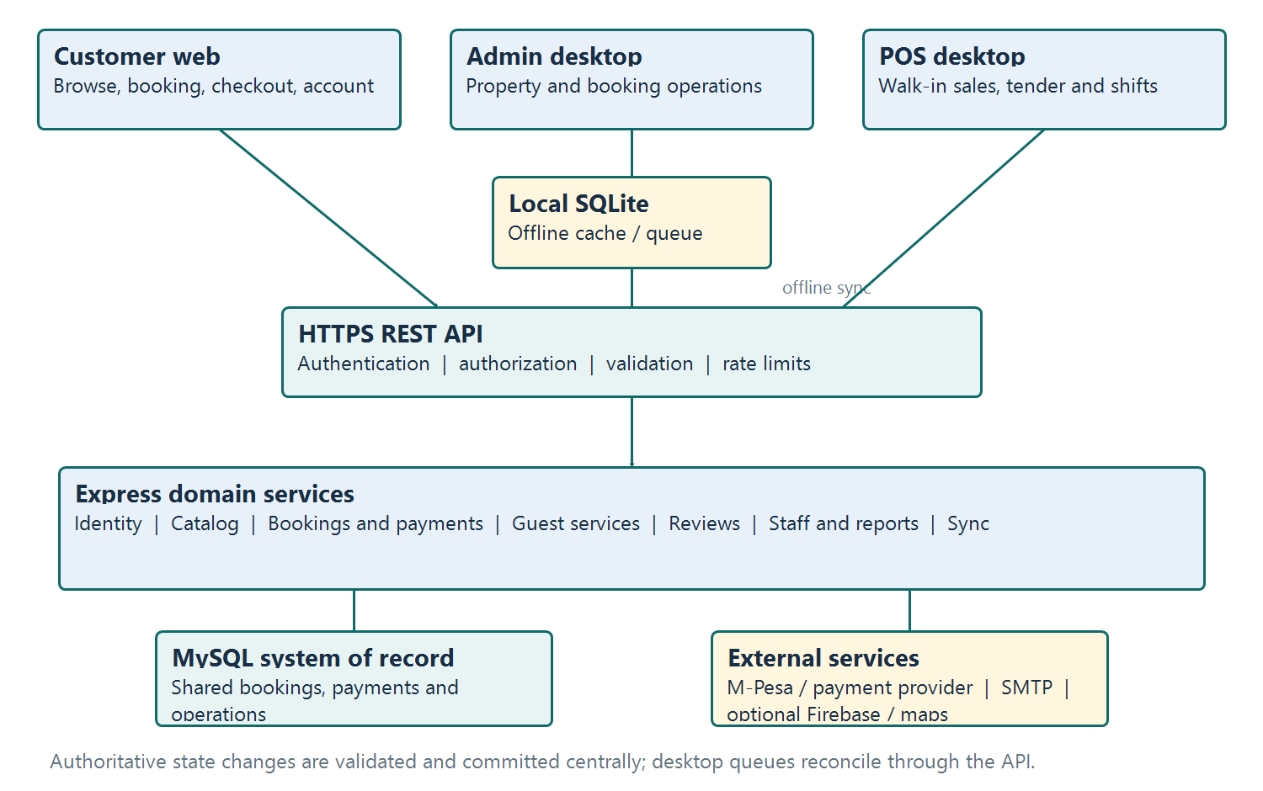

Flow: Customer / Admin / POS -> HTTPS API -> domain services -> MySQL. Admin and POS may also use local SQLite for explicitly supported offline tasks -> sync API -> MySQL. Provider callbacks return through the API and are verified before payment state changes.

Figure C-2. Booking and payment sequence
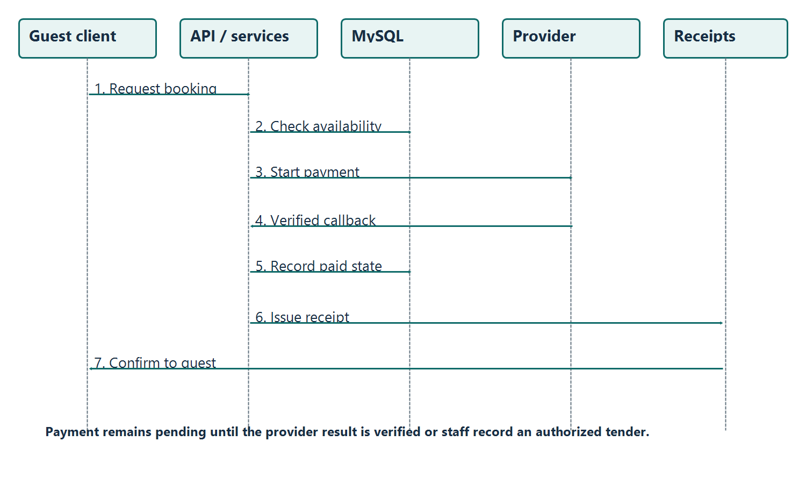

Figure C-3. Offline operation and synchronization sequence
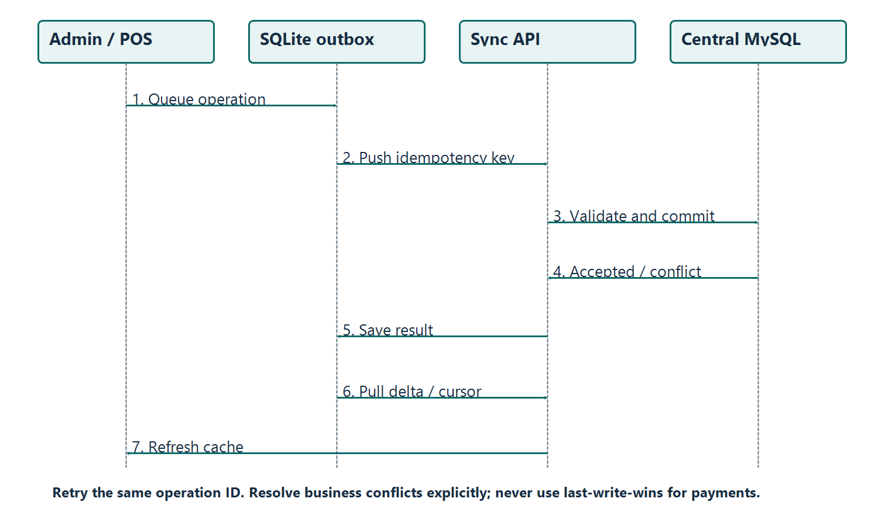

The current sync service exposes timestamp-based delta pulls and pushes. Durable retries, per-record conflict outcomes and device-level idempotency are recommended design extensions; verify their implementation before relying on them.

Appendix D. Extended Component Design
Status key: Existing means repository routes, services or schema show a corresponding capability. Proposed means a design extension recommended for a future release and not claimed as implemented.

Table D-1. Current and proposed supporting components
Component / status | Responsibility and interfaces | Data / controls | Priority
Booking & availability / Existing | BookingService and property/booking routes; date checks and lifecycle transitions | MySQL booking rows; transactionally recheck overlap on create/confirm | P0: concurrency verification
Payment reconciliation / Existing + hardening | PaymentService, M-Pesa adapter and callbacks; provider reference maps to payment | MySQL payment/receipt records; callback verification, replay protection, idempotency and reconciliation | P0
Desktop sync / Existing + hardening | SyncService push/pull and local SQLite clients | Proposed outbox fields: operation_id, device_id, attempts, next_retry_at, last_error, payload_hash, result | P0
Notification delivery queue / Proposed | Outbox worker sends booking, payment and service messages; retry and dead-letter review | Proposed notification_jobs: event_id, channel, recipient, template, status, attempts, next_attempt_at, provider_id; minimize PII | P1
Housekeeping & maintenance work orders / Proposed | Admin board assigns cleaning/repair tasks from checkout, guest report or inspection; due date and status workflow | Proposed work_orders: property_id, booking_id nullable, category, priority, assignee_id, due_at, state, notes; append status history | P1
Audit and operational observability / Existing + extend | AuditLogs and health endpoints record actor/action/entity; metrics track API, DB, sync and providers | Existing audit_logs; proposed correlation_id, result, device source and redacted change summary; alert callback failures/backlog | P1
Reporting/export jobs / Existing + extend | ReportService and reports routes; expensive exports become async jobs with status/download endpoint | Persist job parameters/file metadata; role-scoped access, expiry, pagination and export audit | P2
Accessibility and UI feedback / Proposed quality gate | Shared form states, labels, keyboard operation, focus and status messages across web/admin workflows | WCAG 2.2 AA-oriented verification target; test contrast, visible focus, reflow and target size | P1

Table D-2. Data ownership and consistency rules
Record / fact | Authoritative owner | Consistency rule
Property and availability | MySQL / backend API | Every booking write checks current server availability; client cache is advisory
Booking status and total | MySQL / BookingService | Only approved server transitions; retain price/tax/discount snapshot for reconciliation
Payment status and receipt | MySQL / PaymentService | Verified callback or authorized tender; idempotent provider reference; never infer paid from client return URL
Review eligibility and visibility | MySQL / ReviewService | One review per eligible checked-out booking; pending moderation before public display
Offline work queue | SQLite until acknowledged, then MySQL | Store operation ID and per-item result; conflicts require explicit resolution for booking/payment facts
Audit history | Central audit log | Append-only application behavior, least-privilege access, timestamps and correlation IDs; exclude secrets/payment credentials

Table D-3. Recommended verification criteria
Area | Design acceptance check | Evidence to retain
Authorization | A customer cannot read/change another customerâ€™s booking/payment by changing an object ID; test cashier/admin permissions by action | Authorization matrix and object-level security review
Booking concurrency | Two simultaneous requests for the same property/date range cannot both confirm | Concurrent request results and transaction/constraint evidence
Payment callbacks | Invalid, duplicate, out-of-order and delayed callbacks do not create false paid states or duplicate receipts | Provider sandbox traces and reconciliation results
Offline sync | Replay is harmless; conflicts are surfaced; cursor survives restart without skipping updates | Disconnect/reconnect test with per-operation outcomes
Accessibility | Keyboard-only guest/staff task completion; visible focus, labeled errors, contrast and narrow viewport review | WCAG 2.2 AA-oriented checklist and issue log; no conformance claim until audited
Recovery/monitoring | Restore backup and record recovery time; alert on API/DB outage, callback errors and growing sync backlog | Restore rehearsal and alert evidence

Appendix E. Research and Design Basis
The external sources below inform recommendations; they do not certify CozyStay. OWASP API Security Top 10 highlights broken object-level authorization and unrestricted resource consumption, supporting ownership checks on identifier-based API operations and limits on list, upload and report workloads [1]. OWASP ASVS provides a structured basis for verifying application and service security controls [2]. WCAG 2.2 is a proposed accessibility target for keyboard access, focus, contrast, reflow and target size [3].
[1] OWASP Foundation. OWASP API Security Top 10, 2023 edition. https://api-security.owasp.org/editions/2023/en/ (accessed 26 October 2026).
[2] OWASP Foundation. Application Security Verification Standard (ASVS), version 5.0.0, published 30 May 2025. https://asvs.owasp.org/ (accessed 26 October 2026).
[3] World Wide Web Consortium (W3C). Web Content Accessibility Guidelines (WCAG) 2.2, W3C Recommendation, 12 December 2024. https://www.w3.org/TR/WCAG22/ (accessed 26 October 2026).
Repository evidence reviewed for this revision: database/schema.sql; backend/src/services/BookingService.js, PaymentService.js, SyncService.js and NotificationService.js; backend/src/routes/audit.js and notifications.js; admin-client/src/sync/SyncManager.js; pos-system/POSSystem/Sync/SyncService.cs; README.md and docs/API.md, docs/DATABASE.md and docs/PRODUCT_DIFFERENTIATION.md.

